Assignment #2 Latinx Fiction Book Club
Book talks & Book Club Discussion Plan

Solia Martinez-Jacobs

INFO 260A Programs and Services for Children
San Jose State University

Penny Peck

July 1, 2019

Author’s Note:
I spoke with Dawn Harby at the Alameda Free Library about their Children’s book club. Since I have not yet worked at a library, I am basing this project off of the information I received from her. Dawn said that book club members are chosen by lottery in August, and that 15 children are chosen to participate and meet once a month from October through May. Only one staff member runs the book club meetings, and she says the bulk of the budget for book club goes into purchasing the books (Alameda Free Library, July 2019.)

Book Selection
Torres, Jennifer. Stef Soto, Taco Queen. Little, Brown Books For Young Readers, 2017. [176 p.]. Hardcover, $16.99 ISBN 9780316306867

Stef Soto is your average seventh grader with a not-so-average Tia Perla, who isn’t her Tia at all, but her family’s taco truck. Everything is going great: everyone loves Papi’s food, and Stef’s friend Amanda even wins tickets on the radio for the hottest concert in town: Viviana Vega! After the contest, everything starts to fall apart: kids start calling Stef the Taco Queen and teasing her because of the truck and her overprotective parents. Stef’s art class, her favorite subject, is running low on supplies and they need to raise money fast, and the city wants to put restrictions on food trucks which will put the Sotos at risk of losing Tia Perla forever. Will Stef ditch Tia Perla and her family to be more independent, or will she join forces with her friends to save her family’s American Dream?

Book Discussion Group
For our October Book Club, the book selection is Stef Soto, Taco Queen by Jennifer Torres. This month’s theme is Latinx fiction and will feature read-alikes from three other novels by Latina writers. Children will be able to take home a handout with these read-alike recommendations. We anticipate 15 children in attendance ranging from 4th-6th grade, all of whom have been pre-selected by lottery. The book club lottery was advertised on Facebook, the library website, and flyers were posted at each library branch and distributed to nearby schools prior to the end of the schoolyear (alamedafreelibrary.org).
Handouts for each activity will be available for each child at the different activity stations, with the exception of the taco truck activity, which will have a sign with the instructions on the table. Before the program, sample projects will be made to display at each station. Materials will be prepped (tissue paper cut to the right sizes, signage and copies made), and the refreshments will be purchased earlier in the day. The Abuelita hot chocolate can be made in a crockpot and ready for the end of the meeting. At least 2 parent volunteers or older teen siblings can assist with the activities during the meeting. A budget will be included at the end in the reference section.

The Agenda for the book Club is as follows:
- Check-in and Nametags
- Icebreaker and introductions
- Book Discussion
- Tortilla Making Demonstration
- Art Stations- Book Related Craft Activities
- Closing & Refreshments (Abuelita Hot Chocolate & Conchas)

Welcome & Registration
Each child will sign themselves into the book club on the sign in clipboard. We will have nametag stickers and markers next to the clipboard. Children will be asked to come up with a food-related nickname and to write the nickname on their nametag as well. They can also decorate their nametag with pictures if they would like. Music will be playing in the background, either on a Latino music playlist or with CDs from various Latino artists such as Celia Cruz and Selena. Once everyone has signed in, we will take our seats and begin the introductions. Library staff will monitor sign-in and registration so that they can greet each child as they enter. Parent Volunteers can help prepare the tortilla making station and ensure other art stations are ready to go.

Ice Breaker & Introductions
We will review the group expectations for book club and do an ice breaker. Children will use the think-pair-share method to introduce themselves (adlit.org, n.d.). Children will pair up and introduce themselves to each other and each will have 30 seconds to explain why they chose their food-nickname. After a minute, we will go around the circle and everyone will introduce their partner (including their food nickname to the group). Introductions will be followed by a book discussion.

Discussion Questions:
- On page 10 Stef says “﻿People always ask if I get sick of taco truck food, if I’m bored eating the same thing night after night. But what they don’t know is that it’s never the same thing. Somehow Papi always prepares exactly what I’m craving.” Obviously, food plays a large and important role in this story. Why do you think that is? What are some of your favorite foods? Is there a certain food that makes you feel better when you are sad or upset? Do you ever get tired of it? Why or why not?
- Stef talks about her family’s taco truck Tia Perla, as if it is actually a member of the family. If Tia Perla was a person and not a taco truck, what do you think she would be like? How would she look? How do you think she and Stef would get along?
- How does Stef’s relationship to Tia Perla change from the beginning to the end of the novel? Why do you think this happens? What about the relationship with her parents?
- Stef uses her art to express her feelings about what is happening in her life, and her friends Amanda and Arthur use soccer and music in a similar way. What sort of hobbies do you use to express yourself or make yourself feel better?
- The Soto family’s dream was to own their own restaurant, working hard to keep Tia Perla running. What do you think of the regulations the city tried to place on the food trucks? Was it fair of Papi to ask Stef to do the speech in front of the city council? What do you think you would do if you were in Stef’s shoes?
Book Related Activities
There will be five book related activities set up at different table stations. A parent volunteer can run the tortilla making station. We will do a demonstration for the group, and then groups of 3 can rotate making tortillas while the rest of the children focus on other activities. We will play music in the background once the tortilla demonstration is over and children are working on their activities. Each activity is on it’s own page, making them easily printable for the book club as needed.

Closing
Children will enjoy Abuelita hot chocolate and Conchas, a mexican sweet bread, from Peña’s Bakery (thefrugalfoodiemama.com, Dec. 2012) (https://www.yelp.com/biz/peñas-bakery-oakland-3, n.d.). We will close book club by sharing a Rose and Thorn (one positive and one negative) about the book or book club meeting and activities (Edutopia.org, November 2018). Children are welcome to continue to socialize with each other while they finish their refreshments and will be reminded about the next month’s book club selection and dates.

Activity 1: Tortilla Making

Materials Needed:
- Tortilla Press
- Parchment Paper
- Electric Griddle or Hot plate & Non-stick pan or Comal
- Adult Helper

We will demonstrate tortilla-making to the group before excusing the children to other activities. Library staff or a parent volunteer will mix three recipes worth of tortilla dough prior to the book club meeting and we will still have the ingredients available to display near the skillet or griddle. The recipe and directions for the activity are taken directly from Jennifer Torres’s website and can be found on the following page.
HOMEMADE TORTILLAS
Taken from the website of Jennifer Torres, author of Stef Soto, Taco Queen.

https://jenntorres.com/books/stef/activities-and-resources-stef-soto-taco-queen/homemade-tortillas/

INGREDIENTS
- 2 cups flour
- 1 teaspoon salt
- 1/4 cup shortening (I’ve also used margarine, and it’s worked all right)
- 1/2 to 3/4 cup water
- *It’s not an ingredient exactly, but I highly recommend parchment paper as well.

DIRECTIONS
- Mix the flour, salt and shortening in a medium bowl.
- Add water, starting with 1/2 cup and stir until dough forms. If the dough is dry and crumbly, add a little more water. If you go overboard and the dough gets sticky, add a little more flour.
- Break off pieces of dough and roll into balls about the size of a golf ball. You should have about a dozen. Cover them with a towel and leave them to rest for 15-20 minutes.
- Now for the fun part: Place the dough between two sheets of parchment paper and press into tortillas. Don’t have a nifty tortilla press? Not a big deal. It’s a little more work, but you can use a rolling pin—shoot for about 1/8 inch thick.
- Warm the tortillas on a hot, shallow skillet, about 2-3 minutes on each side. I flip when golden brown spots start to appear.
- Enjoy!

Activity 2: Resist Art
﻿
He brushes a wash of violet over the paper, then switches to blue and then to green. The colors bloom on the page. They spill into one another in liquid bursts—except for where Mr. Salazar had sketched with his crayon. The mystery drawing turns out to be a spiderweb, its strands gleaming white through all that color. Is the wax holding back the free-flowing paint, keeping it from going where it wants to go? No, I decide. It’s something else. The wax is shining through, bold and bright and refusing to be painted over.

--Stef Soto, Taco Queen p.30-31 (Kindle Edition)

Materials Needed:
- Paper or Cardstock
- Watercolor Paint
- Paintbrushes
- Cups or Bowls for Water
- White Crayons

Draw a picture or pattern on the paper with a white crayon. Paint over the pattern with the watercolors and watch what happens! Wait at least 30 minutes before hanging up or the paint may run together.

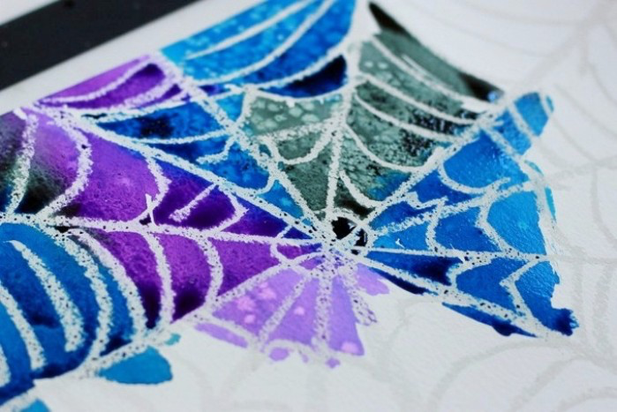
Photo from letslassothemoon.com
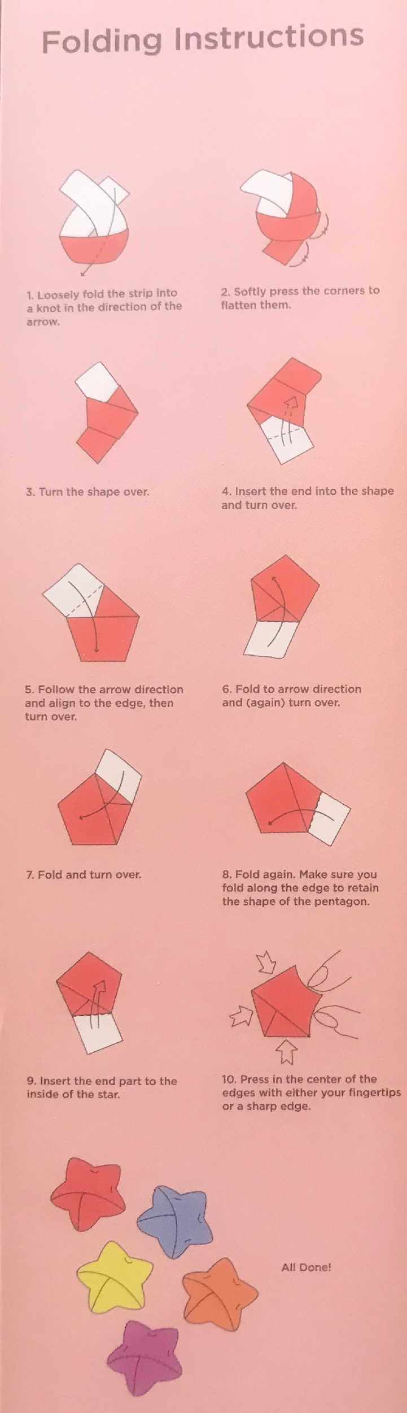
Activity 3: Paper Stars
Materials Needed:
- Pre-cut paper strips
- Gift Wrap, magazines or newspapers
- Scissors
- Ruler or Yardstick

For the dance, Amanda teaches the other kids how to make paper stars to use as decorations. They make larger paper stars out of gift wrap, but smaller paper stars are very common. Paper stars originated in Japan, and are very simple to make. They are often called Lucky Stars, and are given as gifts.

Follow the diagram to the left in order to make a paper star! If you want to make a larger paper star, use the ruler to measure out the length on a piece of paper. The ratio is 1:13. If you want a 1” wide star, the strip must be 1” wide by 13” long. Experiment by using gift wrap, magazines or newspaper instead of the pre-cut strips. How big or small can you make your stars?

Photo taken by Solia Martinez-Jacobs from Daiso Origami Star Paper Packaging.

Activity 4: Make your own Taco Truck
Materials Needed:
- Crayons, Colored Pencils, Markers
- Scissors
- Glue sticks
- Taco Truck Printable from Jennifer Torres’s website: https://jenntorres.com/2016/09/04/make-your-own-taco-truck/

Decorate the taco truck however you’d like using the crayons, colored pencils and markers. Cut along the outline of the drawing, including the flaps! Crease the solid black lines at the base of the flaps, and the four sides of the taco truck. Use glue or tape to connect the flaps to the sides of the taco truck, and get ready to hit the road! Is your truck a taco truck or is it another type of food truck? What would you call it? What’s on the menu?

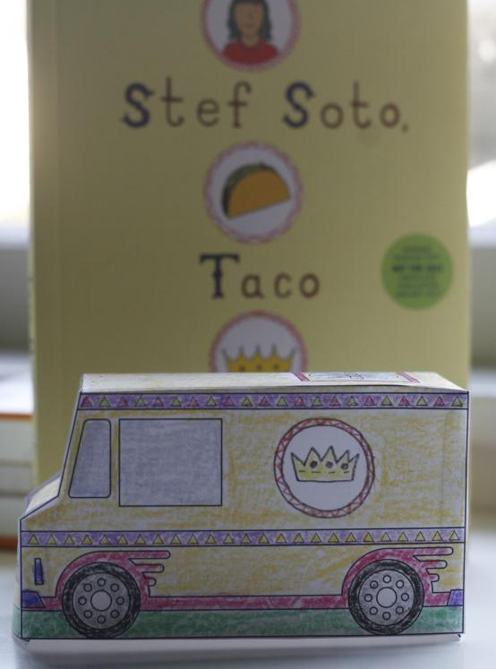 Photo from https://jenntorres.com

Activity 5: Tissue Paper Flowers
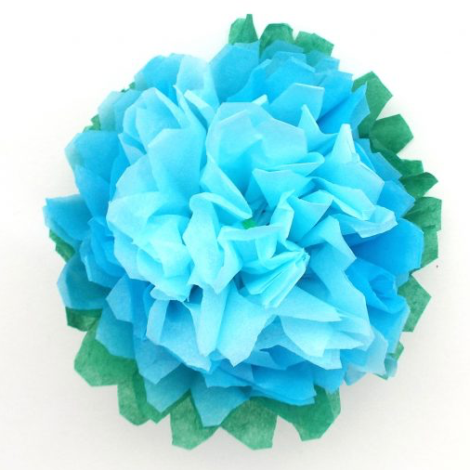Photo from tigerlilyloves.com/diy-tissue-paper-flower

Materials Needed:
- Scissors
- Tissue paper (at least 6 small sheets per flower, cut into small rectangles of the same size, or circles of the same size. These can be pre-cut to insure uniformity.)
- Pipe Cleaners or Floral Wire

Flower # 1- Basic Flower:
Step 1: Take 6 rectangular pieces of tissue paper and lay them flat together in a stack on the table. The color you want on the outside of the flower should be at the bottom of the stack, and the color you want on the inside should be on the top.

Step 2: Fold the 6 pieces of paper accordion/fan style (equal size, forward and backward) until you have what looks like a small strip.

Step 3: Take the pipe cleaner/floral wire and place it in the middle of the tissue paper strip, leaving about 1” above the tissue paper. Fold the pipe cleaner/floral wire over the top of the tissue paper and twist the pipe cleaner/wire around itself. This is your stem.

Step 4 (optional): Trim the edges of the tissue paper to give your flower petals shape. Try cutting the edge to a round “C” shape, cutting the edges into triangular points, or slitting the edges in 2 or 3 pieces for different looks.

Step 5: Carefully separate each tissue paper layer by gently pulling upward. Go slowly or you might tear the tissue paper. Don’t worry how it looks after the first layer: gently separate each layer and puff them out as needed. Don’t forget to puff out the bottom layer too!

Step 6: Shape and puff out the flower as you’d like. Ta Da! Make someone you love a bouquet, or make yourself a flower crown!

To make a Flower Crown, fold the pipe cleaner/floral wire in half during step 3. When all your flowers are finished, twist one edge of the stem together with the edge from another flower. Continue until the crown fits your head and you’ll have a crown ready for any Danza, Fiesta or even Día De Los Muertos!

Flower #2- Carnation
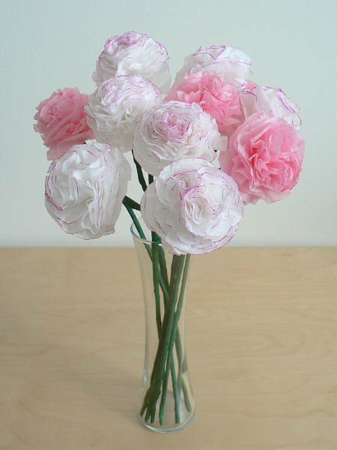
Photo from www.planetjune.com/blog/papercraft/tissue-paper-carnations/
Step 1: Take 6 tissue paper circles and lay them flat together in a stack on the table. If you are using more than one color, the color you want on the outside of the flower should be at the bottom of the stack. If you are only using one color tissue paper, try experimenting with coloring on just the edges of the tissue paper for a cool effect.

Step 2: Draw a small dot in the center of the top circle. This is where you will put your pipe cleaner stem.

Step 3: Carefully poke your pipe cleaner through the dot and all 6 layers of tissue paper. Make a small loop and feed the end through the center again. Twist the pipe cleaner around itself to make the stem.

Step 4: Carefully separate each tissue paper layer by gently pulling upward. This flower doesn’t have the same structure as the first one, so you will need to puff out each layer to give it more shape. Do this for all 6 layers, and don’t forget the bottom! Puff the layers to shape the flower.

If you Liked Stef Soto, Taco Queen try these books!

Merci Suárez Changes Gears by Meg Medina

Medina, Meg. Merci Suarez Changes Gears. Candlewick Press, 2018. [368 p.] Hardcover. $16.99 ISBN 9780763690496

Merci Suarez lives in one of three pink houses called Las Casitas: one belongs to Merci and her parents, one to Aunt Inés and her twins, and the other to her Grandparents. Merci is beginning 6th grade at a fancy Florida private school, where she and her brother, Roli are on scholarship and Mami and Papi always remind them to do their best and stay out of trouble. As part of her scholarship, Merci has to join the Sunshine Buddies and help the new kid, Michael Clark, which causes lots of drama with the popular Edna. As if that wasn’t enough, Merci’s grandfather, Lolo, isn’t acting like her Lolo: he falls during a Sunday bike ride, acts like he’s back in Cuba with his late brother, and even forgets Merci’s name. Merci’s family prides themselves on not keeping secrets, but is Lolo’s secret too big to keep, or will it tear the Suárez family apart?

The First Rule of Punk by Celia C. Pérez

Perez, Celia C. The First Rule of Punk. Penguin Young Readers Group, 2017. [336 p.] Hardcover. $17.99 ISBN 9780425290408

Malú (Maria Luisa) is caught between the two worlds of her divorced parents: her White American dad is a punk-rock record store owner, and her college-professor mom, (who Malú has dubbed “Super Mexican”), just wants her to be a proper Señorita. Malú loves living the punk-rock life with her dad, wearing beat up Chuck Taylors, collecting vinyl, and making zines about anything and everything. But Super Mexican’s job forces them to move from sunny Florida to Chicago. Malú lives her best punk life and shows up to her first day of 7th grade dressed like a rocker…and ends up with a dress code violation and a new (temporarily) blue-haired friend, Joe. Can Malú find a way to fit in while she fights to stand out?

The Revolution of Evelyn Serrano by Sonia Manzano

Manzano, Sonia. The Revolution of Evelyn Serrano. Scholastic, Inc., 2012. [ 224 p.] Hardcover. $17.99. ISBN 9780545325059

Rosa María Evelyn del Carmen Serrano is growing up in the Bronx in 1969. She decides to Americanize her name and asks to be called Evelyn, which her parents are constantly forgetting. Out of the blue her eccentric Abuela comes from Puerto Rico to live with Evelyn and her family, and tensions start to rise not only in the Serrano household, but in the Spanish Harlem community around them. The Young Lords, a Puerto Rican youth activist group start a garbage fire which sparks the neighborhood to take action against the lack of resources and support. Based on real-life events, will Evelyn stand and fight for her Puerto Rican heritage, or blend into the background as an all-American girl?

Materials & Pricing List

Item | Amount Needed | Notes | Cost | Purchase Link
Name tag Stickers | 25 | 500 ct. | $10.99 | https://www.amazon.com/APLANET-Colorful-NameTags-Stickers-Ordinary/dp/B074C4N8WJ/ref=sr_1_1_sspa?keywords=name+tag+stickers&qid=1562045909&s=gateway&sr=8-1-spons&psc=1
Crayons |  | 12 color, 800 piece classpack.. | $41.03 | https://www.amazon.com/Crayola-Classpack-Assortment-Educational-All-Purpose/dp/B00006IBPK/ref=sr_1_3?crid=3TULNT8S0OMEQ&keywords=crayons+classpack&qid=1562046309&s=gateway&sprefix=crayons+class%2Caps%2C189&sr=8-3
Markers (broad tip) |  | 16 color, 256 piece classpack. | $56.88 | https://www.amazon.com/Crayola-Markers-Classroom-Educational-All-Purpose/dp/B0002T3WLS/ref=sr_1_1_sspa?keywords=markers+classpack&qid=1562046421&s=gateway&sr=8-1-spons&psc=1
Markers (fine line) |  | 10 color, 200 ct classpack | $44.97 | https://www.amazon.com/Crayola-BIN8210-Non-Washable-Classpack-Markers/dp/B0006ZIGBO/ref=sr_1_5?keywords=markers+classpack&qid=1562046517&s=gateway&sr=8-5
Colored Pencils |  | 14 color, 456 ct. classpack | $61.90 | https://www.amazon.com/Crayola-BIN8462-Colored-Pencil-Classpack/dp/B002NOV91U/ref=sr_1_1_sspa?keywords=colored+pencils+classpack&qid=1562046599&s=gateway&sr=8-1-spons&psc=1
Watercolor Pallets | 5 | 8 color, 40 ct. classpack | $39.98 | https://www.amazon.com/Creative-Kids-Classroom-Watercolor-Paint/dp/B07DXGCK98/ref=sr_1_1_sspa?keywords=watercolor+classpack&qid=1562046674&s=gateway&sr=8-1-spons&psc=1
Scissors | 17 pairs | 5” pointed tip scissors, 12 ct. | $10.97 | https://www.amazon.com/Schoolworks-153520-1004-Blunt-Scissors-Classpack/dp/B005NAGJJI/ref=sr_1_3?keywords=scissors%2C%2Bclasspack&qid=1562046805&s=gateway&sr=8-3&th=1
Rulers | 5 | 30 pack | $13.99 | https://www.amazon.com/Blue-Summit-Supplies-Shatterproof-Assorted/dp/B07LGCYR5B/ref=sr_1_1_sspa?keywords=rulers&qid=1562046903&s=gateway&sr=8-1-spons&psc=1
Flour | 48oz | 5 lb for tortilla making | $2.89 | https://shop.safeway.com/product-details.117100059.html
Salt |  | 26 oz for tortilla making | $1.09 | https://shop.safeway.com/product-details.114100006.html
Shortening |  | 16 oz for tortilla making | $5.19 | https://shop.safeway.com/product-details.215010001.html
Parchment Paper | ~ 4 feet | 60 ft  For tortilla making | $4.74 | https://www.amazon.com/Reynolds-Kitchens-Parchment-Non-Stick-Square/dp/B07F6F631N/ref=sr_1_1_sspa?keywords=parchment+paper&qid=1562047456&s=gateway&sr=8-1-spons&psc=1
Paper Cups | 30 | Hot or cold, 8 oz 150 count | $13.29 | https://www.amazon.com/TashiBox-White-Drink-Paper-Cups/dp/B07146ZG1X/ref=sr_1_5?keywords=paper+cups+hot+or+cold&qid=1562047312&s=gateway&sr=8-5
Gift Wrap |  | Donated
Old Newspapers |  | Donated or recycled
Old Magazines |  | Donated or recycled
Origami Star Paper | 3 packs | 200 strips per pack. For book club | $1.50 | Available in Daiso Stores.  Daiso Wholesale Website: https://www.daisojapan.com
Tissue Paper | 20 sheets | 180 sheets, 36 colors | $16.99 | https://www.amazon.com/Supla-Wrapping-Birthday-Festival-Decorative/dp/B07KN1KX54/ref=sr_1_6?keywords=tissue+paper&qid=1562048027&s=gateway&sr=8-6
Pipe Cleaners |  | 600 pc. | $11.99 | https://www.amazon.com/Acerich-Assorted-Cleaners-Decorations-Chenille/dp/B07BNBCYCL/ref=sr_1_1_sspa?keywords=pipe+cleaners&qid=1562047980&s=gateway&sr=8-1-spons&psc=1
Glue Sticks | 10 | 60 pack | $12.99 | https://www.amazon.com/AmazonBasics-Purple-Washable-0-24-oz-30-Pack/dp/B07H415XCM/ref=sr_1_1_sspa?keywords=glue+sticks&qid=1562048089&s=gateway&sr=8-1-spons&psc=1
Tortilla Press | 1 | Donated or Purchased | $13.99 | https://www.amazon.com/Alpha-Living-Tortilla-Pataconera-50421/dp/B07FXJHMPZ/ref=sr_1_5?keywords=tortilla+press&qid=1562048252&s=gateway&sr=8-5
Electric Griddle | 1 | Donated or Purchased | $33.38 | https://www.amazon.com/Presto-22-inch-Electric-Griddle-Removable/dp/B005FYF3OY/ref=sr_1_3?keywords=electric+griddle&qid=1562048159&s=gateway&sr=8-3
White Multimedia Art Paper |  | 500 ct, 9x12” | $18.36 | https://www.amazon.com/Pacon-Art1st-Mixed-Media-Sheets/dp/B003Y7C9FK/ref=sr_1_1_sspa?keywords=multimedia+paper&qid=1562048305&s=gateway&sr=8-1-spons&psc=1
Milk |  | 1 gallon  For book club refreshments | $4.89 | https://shop.safeway.com/product-details.136010121.html
Abuelita Hot Chocolate | 4 tablets | For book club refreshments | $4.59 | https://shop.safeway.com/product-details.127105416.html
Conchas | 20 | For book club refreshments | ~$1 each | Peñas Bakery.  https://www.yelp.com/biz/peñas-bakery-oakland-3?osq=penas+bakery
Crock Pot |  | Donated or Purchased | $29.99 | https://www.target.com/p/crock-pot-7qt-manual-slow-cooker-silver-scv700-ss/-/A-12833835?ref=tgt_adv_XS000000&AFID=google_pla_df&fndsrc=tgtao&CPNG=PLA_Appliances%2BShopping_Local&adgroup=SC_Appliances&LID=700000001170770pgs&network=g&device=c&location=9032059&gclsrc=aw.ds&&gclid=Cj0KCQjw3uboBRDCARIsAO2XcYC1hp_8-fzuLbmuiyJfO31tPq1aFL3FV96OtqCtNTaNuX-ELqULSqkaAuj2EALw_wcB

Unless noted otherwise, supplies should be used for multiple programs besides book club. This budget is assuming that book club restocks supplies at the beginning of each school year. Materials for specific projects will be submitted with each monthly book club plan.

References
Beautiful DIY tissue paper flowers. (2018, September 20). Retrieved from https://tigerlilyloves.com/diy-tissue-paper-flowers/
Blog – PlanetJune by june gilbank » tissue paper carnations. (n.d.) Retrieved from https://www.planetjune.com/blog/papercraft/tissue-paper-carnations/
Booktalks that knock 'em dead. (2007). Teacher Librarian, 35(1), 41-42. Retrieved from http://libaccess.sjlibrary.org/login?url=https://search.ebscohost.com/login.aspx?direct=true&db=eft&AN=502924743&site=ehost-live&scope=site
Classroom strategies | think- pair- share. (n.d.). Retrieved from http://www.adlit.org/strategies/23277/
Felde, K., Emanuel, R. & Perez, C. C. (2018). Episode 62 - the first rule of punk - with celebrity reader chicago mayor rahm emanuel. Retrieved from http://www.bookclubforkids.org/new-blog/2018/2/25/episode-62-the-first-rule-of-punk-with-celebrity-reader-chicago-mayor-rahm-emanuel
Felde, K., Manzano, S. & Iglesias, Y. (2018). Episode 59 - the revolution of evelyn serrano by sonia manzano. Retrieved from http://www.bookclubforkids.org/new-blog/2018/1/15/episode-59-the-revolution-of-evelyn-serrano-by-sonia-manzano
Harby, D., & Martinez-Jacobs, S. (2019). Phone call with Dawn Harby about book clubs. Personal Communication. Retrieved from https://www.alamedafree.org/Childrens-Services/Reading-Programs/Book-Clubs

Origami lucky star (wishing star). (n.d.). Retrieved from https://www.origami-resource-center.com/lucky-star.html
Origami lucky star instructions. (n.d.). Retrieved from https://www.origamiway.com/origami-lucky-star.shtml
Robinson, C. (2012, December 20). A no fuss hot cocoa bar party. Retrieved from https://www.thefrugalfoodiemama.com/2012/12/a-no-fuss-hot-cocoa-bar-party.html

Sanchez, C. (2014, February 27). Easy-to make spring inspired crayon resist watercolor art for kids. Retrieved from https://www.craftsbycourtney.com/how-to-crafts/easy-crayon-resistant-watercolor-kids-art/
Shevrin Venet, A. (2018). A simple but powerful class opening activity. Retrieved from https://www.edutopia.org/article/simple-powerful-class-opening-activity
Torres, J. (n.d.). Homemade tortillas. Retrieved from https://jenntorres.com/books/stef/activities-and-resources-stef-soto-taco-queen/homemade-tortillas/
Torres, J. (n.d.). Make your own taco truck! Retrieved from https://jenntorres.com/2016/09/04/make-your-own-taco-truck/
Torres, J. (n.d.). Prompts for writing and discussion. Retrieved from https://jenntorres.files.wordpress.com/2018/10/stef-soto-taco-queen-3.pdf
Van't hul, J. (n.d.). Spider web art project: A simple (and beautiful) watercolor activity for kids. Retrieved from https://letslassothemoon.com/2014/10/08/spider-web-art-project/

Photo Credits (in order of appearance):
Spider-Web Resist Art: Van't hul, J. (n.d.). Spider web art project: A simple (and beautiful) watercolor activity for kids. Retrieved from https://letslassothemoon.com/2014/10/08/spider-web-art-project/

Folding Instructions for Origami Stars: Photograph by Solia Martinez-Jacobs. Daiso Japanese Discount Store. (2019). Origami star paper 5 designs, 40 sheets each 200 sheets total 25cm x 1cm
Taco Truck: Torres, J. (n.d.). Make your own taco truck! Retrieved from https://jenntorres.com/2016/09/04/make-your-own-taco-truck/
Paper Flower: Beautiful DIY tissue paper flowers. (2018, September 20). Retrieved from https://tigerlilyloves.com/diy-tissue-paper-flowers/

Paper Carnation: Blog – PlanetJune by june gilbank » tissue paper carnations. (n.d., n.d.). Retrieved from https://www.planetjune.com/blog/papercraft/tissue-paper-carnations/

Other Bibliographic Information
Torres, Jennifer. Stef Soto, Taco Queen. Little, Brown Books For Young Readers, 2017. [170 p.]. Kindle Edition, $6.99 ISBN 9780316306850

Perez, Celia C. The First Rule of Punk. Penguin Young Readers Group, 2017. [332 p.] Kindle Edition. $8.99 ISBN 9780425290415

